# Mop simulations

Visualising the physical processes which occur within our bacterial Toximop was an important step in the conclusion of our project. By visualising the cell environment and allowing the manipulation of key properties such as binding probabilities, gate numbers, protein production rates etc., the effects of small changes to key properties of the mopping bacteria could be easily and immediately observed. Furthermore, by the visualisation of the bacterial cell in action, effects over time could be observed and concentrations of particles and proteins displayed in a plot.

The two visualisations created represent two transport mechanism for the transport of proteins from the cytoplasm of *E. coli* to the periplasm. These transport mechanisms are the TAT and SEC pathways (for more details on these pathways, see **ToxiMop – What it is & how it works** (Hyperlink to : <http://2013.igem.org/Team:Dundee/Project/Mop> )). Both the TAT and SEC pathways were tested as possible methods of transport for PP1 molecules into the periplasm and visualisations of such transports were created in an application called Netlogo[1].

Please be aware; the java applets within which these simulations are displayed can oftentake some time in loading. We ask for your patience when attempting to run these applets.

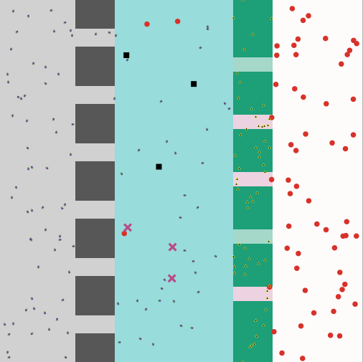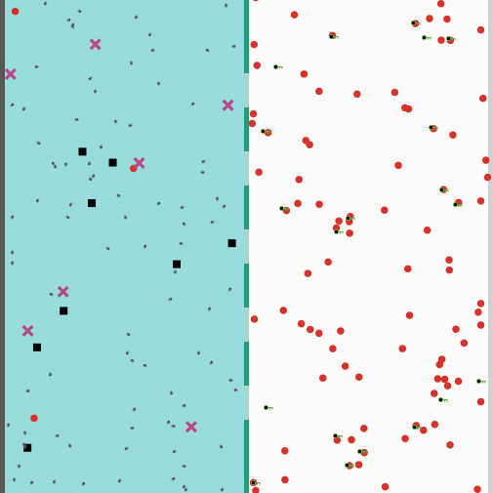 TAT SEC

**Click here** (link to the mop simulation page) to access the full documentation describing the TAT and SEC simulations. If you would like to view the code for both simulations you can find them here: <https://github.com/rcfindlay/iGEM-Dundee-2013>

[1] Wilensky, U. (1999). NetLogo. http://ccl.northwestern.edu/netlogo/. Center for Connected Learning and Computer-Based Modeling, Northwestern University, Evanston, IL.

Software by the Dundee iGEM team is distributed under the terms of the GNU General Public License. GNU General Public License (hyperlink to the gpl-3.0.txt file)